S917V2 5.5 inch Android PDA
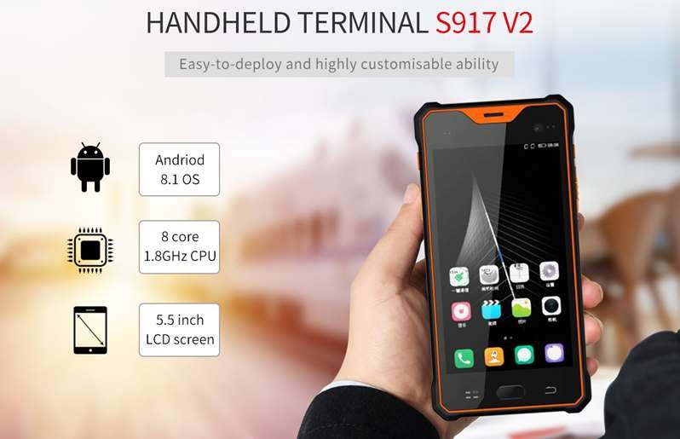
S917V2 Android PDA adopts Qualcomm Snapdragon 625 SDM450, Octa core, 1.8GHz CPU and Android 8.1 operation system; 4G RAM, 64G ROM, 4G LTE. 1920*1080IPS LCD screen is readable under sunlight; can configure optional functions like barcode scanning, RFID reader information acquisition module; has super long battery life with 5000mAH battery; IP65 high reliable three-proof structure water/dust proof; drop resistance from 1.2m.

FEATURES
-----------------------------------------------------------------------------------

Advanced system
Android 8.1 operating system; CPU Qualcomm Snapdragon 625 SDM450, 1.8GHz CPU; RAM 4GB ROM 64GB, Micro SD 128G

Visible under strong light
5.5 inch LCD screen, 1920*1080 IPS capacitive touch screen

Powerful function
Multi function information acquisition configuration (1D/2D bar code scanning, LF/HF/UHF RFID reader)

Multi communication modes
3G/4G, WIFI, Bluetooth and many wireless communication modes

Certification
CCC/CE/ROSH/FCC/IP67/MIL-STD-810

Multi Vehicle holder
Make the tablet charging and fixed easier

SPECIFICATIONS

Standard function
Operating System | Android 8.1
CPU | CPU Qualcomm Snapdragon 625 SDM450, 1.8GHz CPU
GPU | Qualcomm® Adreno™ 509 GPU
RAM | RAM: 4GB
RAM | FLASH: 64GB
Extended Storage | Micro SD, Maximum 128G
USB port | 5 pin MicroUSB; Support to connect U-disk/Mouse/Keyboard/OTG line
OTG | Through OTG can meet 100M network port, network card setup, PPPoE dial-up,  web browsing. Support OTG extend RS232 serial port/485 serial port/RJ45 Serial port
External port | Headphone port
Protection Grade
Industrial Protection Grade | IP65
Drop Grade | Drop resistance from 1.2m
Wireless Communication
Bluetooth | BT4.0 (BLE) class1 transmission distance：10m
GPS | Default GPS: GPS,10m
WIFI | Support IEEE 802.11a/b/g/n/ac (2.4G and 5G bands)
2G/3G/4G LTE | CDMA 1X/EVDO BC0 GSM 850/900/1800/1900 WCDMA B1/B2/B5/B8 TD-SCDMA B34/B39 FDD-LTE B1/B3/B5/B7  TD-LTE B38/B39/B40/B41
Physical Parameters
Display Screen | 5.5 inch LCD screen, 1920*1080 IPS capacitive touch screen, 430NITS
Keyboard | Button: One scan button on the side (the bar code and UHF can be used together), one power button, volume plus or minus button. The 3 physical function  keys (Back Menu HOME)
Camera | 5 million pixels front camera, 13 million pixels rear camera with automatic focus  and lighting function
Headset | 3.5mm audio Interface, has MIC and loudspeaker
LED indicator light | A breathing light, a charging indicator
Flashlight Function | Support, can be used for emergency lighting
Googleplay store | Support
Gravity sensor | Support
Compass | Support

Acceleration sensors | Support
Gyroscope | Support
Light and distance sensor | Support
FM | Support
Fingerprint | For unlocking
Rechargeable Lithium Battery | 3.8V 5000mAh,Support fast charging (QC3.0)
Standby | About 500 hours
Working time | About 8 hours
Dimension | 232*158*22
Weight | 170*84*15mm(host)
Environmental Characteristics
Working Temperature | -10℃ ~ +50℃
Storage Temperature | -40℃ ~ +60℃
Humidity | 5%-95% relative humidity; no condensation
Optional function
Barcode Scanning | 1D Laser Scanner Index(Internal):  Honeywell N4313  Scanning speed: 104 times/second+12 times/second (two way scanning) Scanning distance: 2.5cm-114.3cm  Scanning angle: 47±3°(default) /35±3°(reduced code)
Barcode Scanning | 2D Barcode Scanner Index(Internal):  Optional modules: Newlands EM3296, or Honeywell N3680, or Honeywell N6603  Identification ability: 1D, 2D, OCR  Scanning angle: rotate 360°, incline±50°, deflection ±50° Field of View: Horizontal 36°, vertical 23°  Depth of field: 4cm-23.5cm  Environmental luminance: 0~100,000 LUX
RFID | HF RFID(Internal):  Support 13.56MHZ ,ISO14443A，B, ISO15693 Protocol，Support Mifare card， reading distance 0-3cm
RFID | LF RFID: | In Jacket  134.2KHZ LF RFID, support ISO11784/5 protocol, support to read EM, TEMID, TK cards and compatible cards IC card(FDX/HDX)
RFID | LF RFID: | In Jacket  125KHZ LF RFID, support to read ID card
RFID | UHF RFID | In Jacket  Working frequency: 902-928MHz or 865-868 MHz (M2600, Impinj R2000 chip)  Reading distance: no more than 6m
Pistol grip | With internal batteries and scan button (4800mAh battery inside)

ORDER

Ordering Information |  |  | Module Code | Module Type
Standard / Basic Part
S917V2 Host  CDMA 1X/EVDO BC0 GSM 850/900/1800/1900 WCDMA B1/B2/B5/B8 TD-SCDMA B34/B39 FDD-LTE B1/B3/B5/B7  TD-LTE B38/B39/B40/B41 |  |  | S917V2Q-G | Android 8.1 OS, Qualcomm Snapdragon 625 SDM450, 1.8GHz CPU,4G RAM, 64G ROM  Bluetooth /3G 4G LTE / WIFI / GPS  5.5 inch IPS LCD 1920*1080 5+13 Million Pixels Camera 5000mAh Lithium Battery
Optional Module
Barcode Scanning  (If you need, please choose one only from N,2,8,0) |  | 1D Barcode  scanner | N | 1D Laser Barcode Scanning Honeywell N4313
 |  | 2D Barcode scanner | 2 | 2D Barcode Scanning Newsland EM3296
 |  | 2D Barcode scanner | 8 | 2D Barcode Scanning Honeywell N3680
 |  | 2D Barcode scanner | 0 | 2D Barcode Scanning Honeywell N6603
RFID | LF RFID |  | 4 | LF 134KHZ (FDX)
RFID |  |  | 5 | LF 125KHZ
RFID |  |  | L | LF 134KHz (FDX/HDX)
RFID | HF(NFC) RFID |  | H | HF RFID 13.56Mhz
RFID | UHF RFID |  | M | 902-928MHZ M2600 with R2000 chip
RFID |  |  | E | 865-868MHZ M2600 with R2000 chip

PACKAGING

NO. | Items | Picture
Standard Package | S917V2 Android PDA | 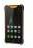
Standard Package | Charger
Standard Package | USB Cable | 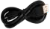
Optional Package | Earphone (Optional)
Optional Package | OTG device USB-LAN RJ45(Optional) | 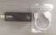
Optional Package | Shoulder belt | 
Optional Package | Bag(Optional) | 
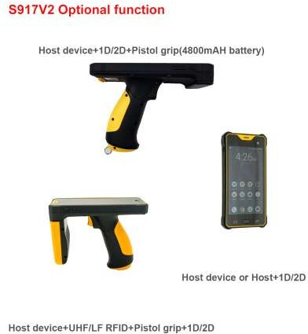

Shandong Senter Electronic Co., Ltd.

Add: No.18, Liuyishan Road, New&Hi-tech Area, Zibo City, Shandong Province, China

255088

Tel/Whatsapp: +86-15288955862

Email: amy@senter.com.cn
Skype: Amy Deng-SENTER

QQ/Wechat: 1547659969

Http: http://en.senter.com.cn/

All information provided by Senter in this data sheet is believed to be accurate. Senter reserves the right to discontinue and change specifications and prices at any time without prior notice. For further details, please refer to our website http://en.senter.com.cn/

